**About JDS**

The objective of JDS is to support human resources development of Sri Lanka. Targeting young government officials, who are expected to be leaders of the country, and to engage in formulating and implementing social and economic development policies after their return. JDS Fellows shall contribute to an expanded and enhanced foundation for bilateral relations with Japan as persons having well-rounded knowledge of Japan.

**Voice from a Returned Fellow**



**Mr. Ravindra Wijenayake**

**Meiji University**

**GS of Governance Studies.**

**Master of Public Policy**

**Deputy Director,**

**Department of Pensions**

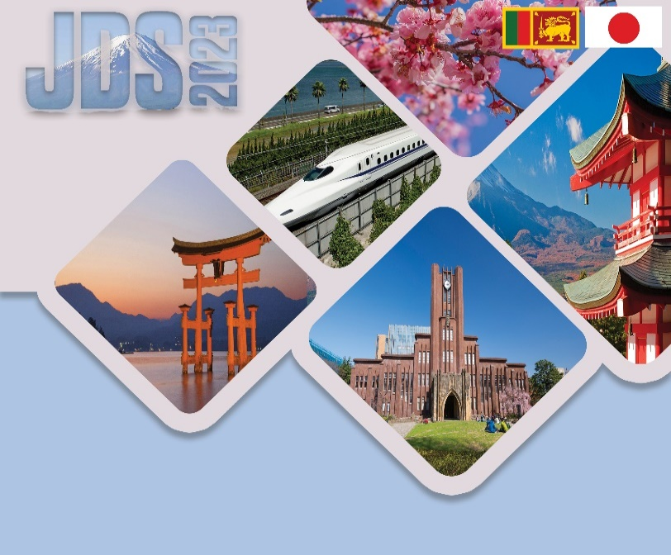

The Project for Human Resource

Development Scholarship

by Japanese Grant AidЛЫК ТАЛАПТАР:

**Eligibility**

1. To be citizens of Sri Lanka
2. Should have a good command of both written and spoken English
3. "Executives/Senior Executives", mentioned in the Public Administration Circular No.06/2006, Annexure II, Page 2, IV Senior Level, and Page 5, 3.10 & 3.11
4. Semi-government staffs (BOI, NBRO, CEA, NWSDB, WMA) can also apply under limited components
5. Applicants are expected to have special interest in studying in Japan as well as motivation to utilize their experience and human network developed through JDS in their career

**Benefits**

* One round trip airfare between Sri Lanka and Japan
* Monthly living allowance
* Full tuition fee at accepting university
* Other designated allowances (ex. buying books, shipping, travelling and seminar attendance, overseas travel insurance, etc.)

As a JDS scholar in 2020, I embarked on an inspiring academic journey pursuing a Master of Public Policy degree at Meiji University, Tokyo, Japan. This opportunity not only enriched my knowledge in public policy and governance but also presented me with a unique chance to address an essential component of our society – providing pension benefits to all individuals of the elderly population. Empowered with this knowledge, I returned to my homeland, Sri Lanka, ready to contribute to implement positive changes in our pension system to ensure a secure and dignified life for our senior citizens.

Beyond the academic realm, Japan offered me a world of diverse and incredible experiences. From scaling the majestic peak of Mount Fuji to immersing myself in the magic of theme parks like Universal Studios and Disneyland, every moment was a testament to the beauty of life and exploration. The joy of witnessing snowfall and engaging in snow games, the excitement of bowling, and the wonder of witnessing cutting-edge technological developments such as modern bullet trains and robotics left an indelible impression on my soul.

More than attractions, I fostered meaningful connections with fellow scholars and professionals. As the Vice President of the Sri Lanka Students' Association in Japan (SLSAJ), I had the privilege of expanding my human network and this invaluable network solidified my commitment to collaborative efforts in the pursuit of positive change.

As I reflect on my time in Japan, I am humbled by the peace, harmony, and invaluable qualities of Japanese society that have left an enduring impact on my way of life. The ethos of compassion, dedication, and innovation ingrained in their culture has inspired me to bring these principles to my work and personal life, contributing to the growth of my beloved country.

**Doctoral Degree Course** is also available!

**Information**



**JICE JDS Project Office in Sri Lanka**

No.93 A 2/1, 2nd Floor, Thimbirigasyaya Road, Colombo 05

Monday to Friday 8:30 to 12:30 / 13:30 to 17:00

TEL: (011)2593331

E‐mail: [jds.srilanka@jice.org](mailto:jds.srilanka@jice.org)

<http://jds‐scholarship.org/country/srilanka/>

Designed by JICE in August 2023

**Study in Japan**

**The Project for Human Resource Development Scholarship (JDS)**

**in Sri Lanka**

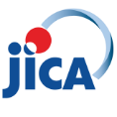



**Benefits**

**Framework**



**Framework of JDS Project**

**Selection Procedure**

Application Closing Date

October 27th, 2023

English & Math Test

December 2nd, 2023

Document Screening

December, 2023

Medical Check

January, 2024

Technical Interview

February, 2024

Comprehensive Interview

March, 2024

Selection Result

April, 2024

Study in Japan

from September, 2024

**Promotion Seminars**

Online promotion seminars are scheduled as below,

* September 15th (Fri) 14:00-15:00 – Sinhala Medium
* September 22nd (Fri) 14:00-15:00 – Sinhala Medium
* October 06th (Fri) 14:00-15:00 – Tamil Medium
* October 17th (Tue)14:00-15:00 – English Medium

University promotion Seminar is also available!　Please visit our website for more information!

Contact [jds.srilanka@jice.org](mailto:jds.srilanka@jice.org) to join!

**http://jds‐scholarship.org/**

Application Guideline (AG), Application Form (AF) and University Information can be downloaded from the website above.

**How to Apply**

1. Access the JDS website
2. Download the Application Form (AF) and other designated forms from the website
3. Complete the Application Form and arrange the all the required documents
4. Submit the application documents as instructed in the Application Guide

